Analysis of 2D and 3D Bezier curve with different control points

2 control points:
- 2D:
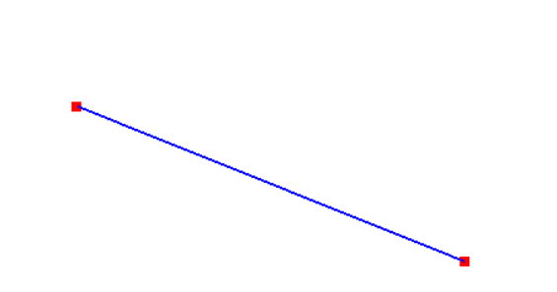

Time complexity (execution time): 0.002648 seconds
Space complexity (memory usage): 8120 bytes
- 3D:
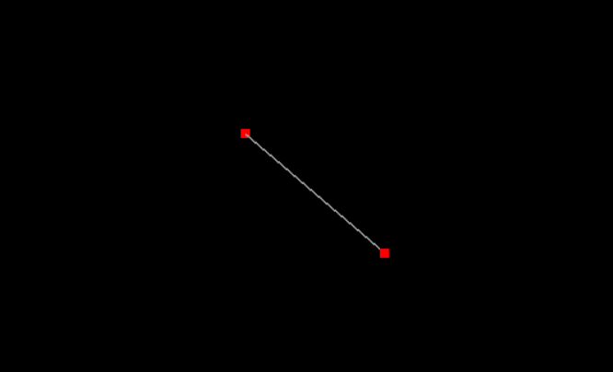
Time complexity (execution time): 0.001007 seconds
Space complexity (memory usage): 8920 bytes
3 Control Points:
- 2D:
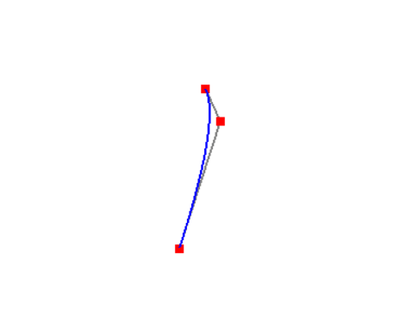
Time complexity (execution time): 0.001465 seconds
Space complexity (memory usage): 8120 bytes
- 3D:
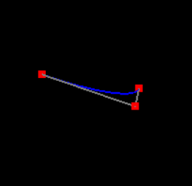
Time complexity (execution time): 0.001506 seconds
Space complexity (memory usage): 8920 bytes

4 Control Points
- 2D:
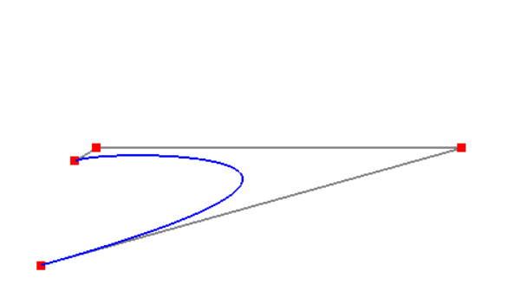
Time complexity (execution time): 0.001025 seconds
Space complexity (memory usage): 8120 bytes
- 3D
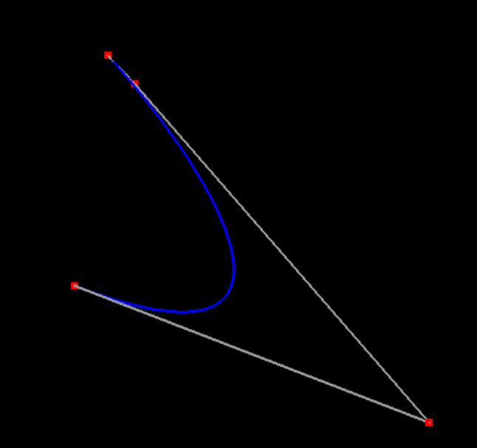
Time complexity (execution time): 0.001003 seconds
Space complexity (memory usage): 17656 bytes
Graph Comparison between Time vs Space Complexity of 2D and 3D:
